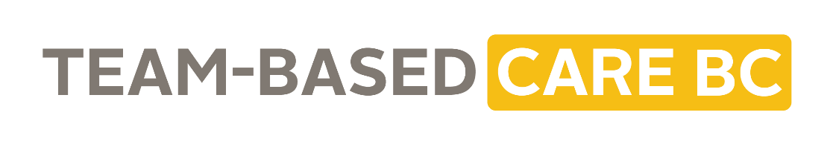
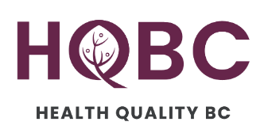
Communications Toolkit:
Team-Based Care: Getting Started

July 2023

Background
Team-Based Care (TBC) is a model of health care delivery where many health professionals work together to support a patient’s needs. For health care workers, TBC can lead to higher job satisfaction, decreased workloads, increased work-life balance and prevention of burnout. For patients, TBC can mean greater continuity of care, improved access to care and improved health and wellness for people with chronic conditions.

While the benefits of TBC are well documented, it has not been universally adopted in BC. There are many reasons for this including a lack of time, staff turnover, misunderstandings about TBC and resistance to change. A provincial Team-Based Care Advisory Group sees the potential to change this.

The Advisory Group is made up of partners throughout the health system and guides work across the province to accelerate its transition to TBC. Administered by Health Quality BC (HQBC), the group has developed a dedicated TBC website and dozens of resources, tools and learning opportunities to support this transition.

About this Toolkit
HQBC designed this toolkit to help health care professionals and communications staff in partner organizations and health authorities promote TBC resources through newsletters, emails, key messages and other communications channels used to reach their health care audiences. Each toolkit is centred on a specific theme and highlights related resources, tools and learning opportunities.

Please feel free to copy and paste the content directly or adapt it to your channels accordingly.

Toolkit theme: Team-Based Care – Getting Started
The content and links in this toolkit will introduce people to teambasedcarebc.ca and resources, and will benefit teams in the early stages of implementing TBC, teams wanting to get started with TBC or anyone who is simply interested in learning more.

Useful Links
- Team-Based Care BC website: https://teambasedcarebc.ca/
- Team Up! Podcast: https://teamuppod.com/
- Team Up! Webinar Series: https://vimeo.com/showcase/8042538
Highlighted Resources
- Team-Based Care Website: The Team-Based Care Website’s content has been developed by the Provincial Team-Based Care Advisory Group, which is an initiative of the Ministry of Health and represents partners from across BC’s health care system. The website includes dozens of resources, tools and learning opportunities to support the implementation of team-based care.
- Team Effectiveness Tool: The Team Effectiveness Tool is a short, multiple-choice assessment tool that gathers information about your team’s values, communication, roles, and existing supports to help guide your learning on team-based care.
- Teamwork Agreement: A great place to start when building a new team or refreshing team vision, purpose and goals.
- Team Up! Podcast: The Team UP! podcast explores different ideas related to team-based primary care, focusing on what is happening here BC.
Key Messages
- Implementing team-based care can feel overwhelming, and it can be hard to know where to get started.
- The Team-based Care BC website has dozens of resources, tools and learning opportunities to help you and your teams through every step of this journey.
- A great place to start is by taking the Team Effectiveness Tool – this assessment tool will help you identify key areas of growth and learning that could benefit your team.
- Next, the Teamwork Agreement is a great first step for building a new team or for refreshing your teams’ vision, purpose and goals.
- Continue your learning with the Team Up! Podcast, which explores different ideas related to team-based primary care and what is happening here in BC.
- The benefits of TBC are well documented for both patients and health care workers – these resources will help you get started on this journey.
Website / Newsletter copy
Use some of or all of this content on your internal website or in a newsletter:
Implementing team-based care (TBC) can feel overwhelming and it can be hard to know where to get started. The Team-Based Care website has dozens of resources, tools and learning opportunities to help you and your teams through every step of this journey. The following tools will support you and your team to take the first steps towards team-based care.
A great place to start is the Team Effectiveness Tool – this assessment tool will help you identify key areas of growth and learning that could benefit your team, and where you may want to start.
Next, the Teamwork Agreement is a great first step for building a new team or for refreshing your teams’ vision, purpose and goals. Continue your learning with the Team Up! Podcast, which explores different ideas related to team-based primary care and what is happening here in BC.

The benefits of TBC are well documented. For health care workers, TBC can lead to higher job satisfaction, decreased workloads, increased work-life balance and prevention of burnout. For patients, TBC can mean greater continuity of care, improved access to care and improved health and wellness for people with chronic conditions.
Stay tuned for more themed resources to help you on your TBC journey. In the meantime, have a read through the website and sign up for the Team Up! Newsletter!
Email copy
This content can be used by leaders to share resources and info about TBC:
Thank you for your continued enthusiasm to develop and improve our efforts to support team-based care (TBC)! TBC is a model of health care delivery where many health professionals work together to support a patient’s needs. A key feature is having patients and their care providers be equal partners in the care. This person- and family-centred model is designed to provide comprehensive shared care through strong, interdisciplinary teams of health care providers.

To support your learning and practice, I wanted to share some resources and tools to help guide your journey.
- The Team-based Care BC website has dozens of resources, tools and learning opportunities to help you and your teams through every step of this journey.
- A great place to start is by taking the Team Effectiveness Tool – this assessment tool will help you identify key areas of growth and learning that could benefit your team.
- Next, the Teamwork Agreement is a great first step for building a new team or for refreshing your teams’ vision, purpose and goals.
- Continue your learning with the Team Up! Podcast, which explores different ideas related to team-based primary care and what is happening here in BC.
Social Media copy
Please feel free to share our social media posts (Twitter/X: @healthqualitybc; Facebook/LinkedIn: @Health Quality BC) or create your own using the below content we’ve drafted for Twitter/X and the TBC logo:
Post 1: The benefits of team-based care are well documented. Wondering how to get started? teambasedcarebc.ca/ has dozens of resources to help you through every step of this journey.
Post 2: Getting started with team-based care and looking for some guidance? A great place to start is the teambasedcarebc.ca/team-effectiveness-tool/ – this tool will help you identify key areas that could benefit your team.
Post 3: If you’re getting started with team-based care, check out this teamwork agreement to help your team determine your shared purpose, commitment and more: https://bcpsqc.ca/wp-content/uploads/2020/07/Teamwork-Agreement_Finalv2.pdf
Post 4: Looking for something new to listen to? Fire up your headphones and hit play on teamuppod.com/ to learn about team-based primary care and what is happening here in BC.
Other Ways to Share
Here are some other ways you can help amplify Team-Based Care in BC.
Share HQBC’s social media posts in your networks, both personal and professional. You can find us at Twitter/X: @healthqualitybc; Facebook/LinkedIn: @Health Quality BC.
Send a note to your friends and colleagues, along with this link to the Team-Based Care BC website, and encourage them to check it out.
Graphics to Support Your Messages
Graphics that you may want to use with your communications are below:
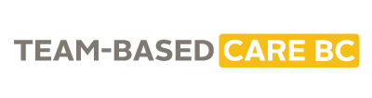
Logo:

